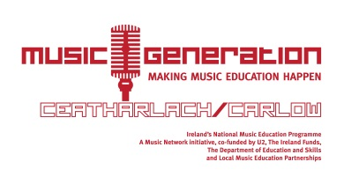

Music Generation Carlow Christmas Concerts

Date | Time | Participant School | Venue
Thurs 11th Dec | 7pm | St. Columba’s NS | St. Columba’s Church
Fri 12th Dec | 11.45am | Naoinra | Naoinra
Sat 13th Dec | 5pm | Piano Duet Club | Holland Pianos*
Mon 15th Dec | 7.30pm | Borris VS | Borris Church
 | 1pm | Nurney (Early Years & Choral)
Tues 16th Dec | 7pm | Kildavin NS
 | 7.30pm | Balllymurphy NS | Ballymurphy Church
 | 11am/11.30am | Tullow Girls | Tullow Girls
 | 10.30am | Ballon NS | Ballon NS
 | 10am/11am | Ballinabranna NS  (choral: in house class performance) | Ballinabranna NS
Wed 17th Dec | 7pm | Kildavin NS
 | 11.45am | St. Mullins | St. Mullins
 | 7.30pm | Borris NS | Borris Church
Thurs 18th Dec | 7pm | Tullow Boys NS | Tullow Parish Church
 | 11.45am | St. Mary’s Bagnelstown | St. Mary’s Bagnelstown
 | 10am & 12.30pm | Queen of the Universe | Queen of the Universe
 | 11am | Mary’s Creche

- This concert is open to the public and all are welcome

