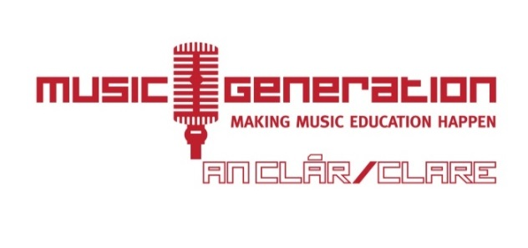
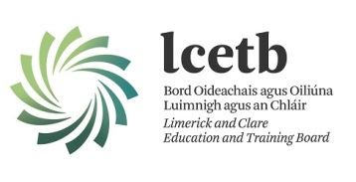

Foirm chun spéis a léiriú chun páirt a ghlacadh in
Expression of Interest Form to partake in The County Clare Trazz Experience.
Student Name:
Student Age:
D.O.B
Contact Details:
Email:
Mobile number:
Address:

Instrument:
Teacher (if currently attending one):
Link to 30 second clip of performance: _________________________________________

Personal Statement: (please state why you would like to join The Clare Trazz Experience):
Signed by applicant:

Signed by parent/guardian: __________________________________________________________
Date: __________________________
Requirements:
Be attending second level education;
An ability to read music;
Enthusiasm and Your chosen instrument (all genres welcome)
Closing date for receipt of applications is Wednesday, January 13th, 2016 to the address below.
Rehearsal Schedule
All rehearsals to take place in An Teach Ceoil, Sráid an Teampaill, Ennistymon,
10-1p.m on
Sunday mornings as follows
January 17, 24;
February 07 and 21;
March 06 and 13 – two consecutive Sundays, due to St. Patrick’s Day and lengthy Easter celebrations;
April 10 and 24
May 08 and 22.
First Performance date, weekend of May 27th.

Music Generation Clare, Limerick and Clare Education and Training Board, Station Road, Ennis, Co. Clare.
065-6866743 info@musicgenerationclare.ie /musicgenerationclare @MusicGenClare

